**Unit 4 The Open Window**

**Summary of the story**

FramtonNuttel, a nervous man, has come to stay in the country for his health. His sister, who thinks he should socialise while he is there, has given him letters of introduction to families in the neighbourhood whom she got to know when she was staying there a few years previously. Framton goes to visit Mrs. Sappleton and, while he is waiting for her to come down, is entertained by her fifteen-year-old niece. The niece tells him that the French window is kept open, even though it is October, because Mrs. Sappleton believes that her husband and her brothers, who were killed in a shooting accident three years before, will come back one day. When Mrs. Sappleton comes down she talks about her husband and her brothers, and how they are going to come back from shooting soon, and Framton, believing that she is deranged, tries to distract her by talking about his health. Then, to his horror, Mrs. Sappleton points out that her husband and her brothers are coming, and he sees them walking towards the window with their dog. He thinks he is seeing ghosts and runs off. Mrs. Sappleton can't understand why he has run away and, when her husband and her brothers come in, she tells them about the odd man who has just left. The niece explains that FramtonNuttel ran away because of the spaniel: he is afraid of dogs since he was hunted by a pack of stray dogs in India and had to spend a night in the newly dug grave with creatures grinning and foaming just above him. The last line summarizes the story, saying of the niece, "Romance at short notice was her speciality."

**The Open Window - Analysis**

"The Open Window" is Saki's most popular short story. It was first collected in Beasts and SuperBeasts in 1914. Saki's wit is at the height of its power in this story of a spontaneous practical joke played upon a visiting stranger. The practical joke recurs in many of Saki's stories, but "The Open Window" is perhaps his most successful and best known example of the type.

Saki dramatizes here the conflict between reality and imagination, demonstrating how difficult it can be to distinguish between them. Not only does the unfortunate Mr. Nuttel fall victim to the story's joke, but so does the reader. The reader is at first inclined to laugh at Nuttel for being so gullible. However, the reader, too, has been taken in by Saki's story and must come to the realization that he or she is also inclined to believe a well-told and interesting tale.

**Style**

“The Open Window” is the story of a deception, perpetrated on an unsuspecting, and constitutionally nervous man, by a young lady whose motivations for lying remain unclear.

**Structure**

The most remarkable of Saki’s devices in “The Open Window” is his construction of the story’s narrative. The structure of the story is actually that of a story-within-a-story. The larger “frame” narrative is that of Mr. Nuttel’s arrival at Mrs. Sappleton’s house for the purpose of introducing himself to her. Within this narrative frame is the second story, that told by Mrs. Sappleton’s niece.

**Symbolism**

The most important symbol in “The Open Window” is the open window itself. When Mrs. Sappleton’s niece tells Mr. Nuttel the story of the lost hunters, the open window comes to symbolize Mrs. Sappleton’s anguish and heartbreak at the loss of her husband and younger brother. When the truth is later revealed, the open window no longer symbolizes anguish but the very deceit itself. Saki uses the symbol ironically by having the open window, an object one might expect would imply honesty, as a symbol of deceit.

**Narration**

“The Open Window” is a third-person narrative, meaning that its action is presented by a narrator who is not himself involved in the story. This allows a narrator to portray events from a variety of points of view, conveying what all of the characters are doing and what they are feeling or thinking. For most of the story, until he runs from the house, the reader shares Mr. Nuttel’s point of view. Like Mr. Nuttel, the reader is at the mercy ofVera’s story. The reader remains, however, after Mr. Nuttel has fled and thus learns that Vera’s story was nothing but a tall tale.

**Historical Context**

Saki does not specify when his story takes place, but it is obvious that the story is set in Edwardian England, the period of time early in the 20th century when King Edward VII ruled England. During this time, England was at the peak of its colonial power and Its people enjoyed wealth and confidence because of their nation's status in the world. The wealthy leisure class was perhaps overly confident, not seeing that political trends in Europe, including military treaties between the various major powers, would lead to World War I and the resulting destruction of their comfortable way of life. It is this complacency that Saki often mocks in his stories.

**Compare & Contrast**

1910s: A rest in the country is often recommended for those city-dwellers suffering from nervous disorders.

Today: Though many people take vacations to relieve stress, the “rest” cure is an antiquated treatment for nerves. Commonly, doctors prescribe medication.

1910s: In polite society, letters of introduction were a common means by which to make oneself known in a new place. Letters of this kind served to guarantee that a move to a new home did not isolate someone from the community.

Today: Most people meet by chance in school or at work rather than through the pre-arranged situations, although dating services and personal ads are common.

1910s: Hunting is a popular sport among the English wealthy classes in the Edwardian Age.

Today: Hunting is a popular sport among all social classes and it is seldom used solely as a means of obtaining food.

**Words and phrases expected of students to understand**

self-possessed

put up with

duly

unduly

a succession of

moping

suggest

spot

out of place

engulf

get on one's nerve

break off

shudder

bustle

rattle

stray

shiver

retreat

mackintosh

bolt out

come up

dash off

lose one's nerve

**Preparatory Work**

1. **Hector Hugh Munro** (18 December 1870 – 14 November 1916), better known by the pen name**Saki**, and also frequently as **H. H. Munro**, was a British writer whose witty, mischievous and sometimes macabre stories satirize Edwardian society and culture. The name 'Saki' is Farsi for 'cup-bearer', and is thought to be taken from either the ancient Persian poem The Rubayat of Omar Khayyam or possibly from the New World Saki monkey Pitheciidae, both being referred to in his acerbically witty and sometimes macabre stories.

Munro had a penchant for mocking the popular customs and manners of Edwardian England. He often did so by depicting characters in a setting and manner that would contrast their behavior with that of the natural world; often demonstrating that the simple and straightforward rules of nature would always trump the vanities of men. This is demonstrated gently in [The Toys of Peace](http://americanliterature.com/author/hh-munro-saki/short-story/the-toys-of-peace) where parents from [Edwardian England](http://en.wikipedia.org/wiki/Edwardian_period) are taught a lesson that is still familiar to modern parents. And it is demonstrated with striking clarity in the highly recommended story [The Interlopers](http://americanliterature.com/author/hh-munro-saki/short-story/the-interlopers). [The Open Window](http://americanliterature.com/author/hh-munro-saki/short-story/the-open-window) is a fine example of his more humorous work is a highly recommended read.

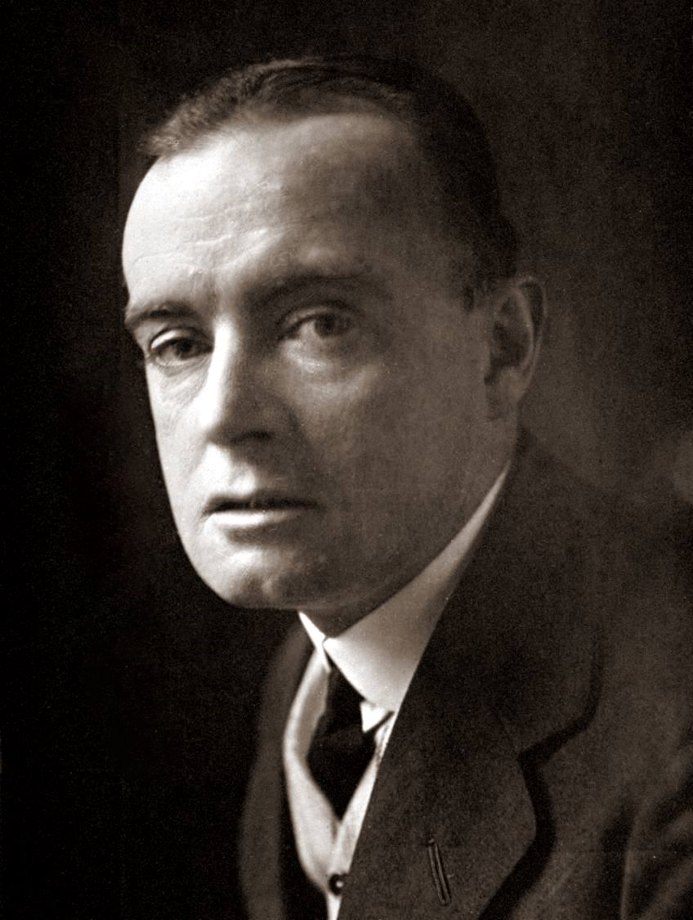Readers that would like to explore the short stories of H.H. Munro (Saki) should consider starting with the following works:

[*The Interlopers*](http://americanliterature.com/author/hh-munro-saki/short-story/the-interlopers)

[*Esme*](http://americanliterature.com/author/hh-munro-saki/short-story/esme)

[*Sredni Vashtar*](http://americanliterature.com/author/hh-munro-saki/short-story/sredni-vashtar)

[*Gabriel-Ernest*](http://americanliterature.com/author/hh-munro-saki/short-story/gabriel-ernest)

[*Toberymoy*](http://americanliterature.com/author/hh-munro-saki/short-story/tobermory)

[*The Schartz-Metterklume Method*](http://americanliterature.com/author/hh-munro-saki/short-story/the-schartz-metterklume-method)

2. Refer to the photo for a typical country house. (from Wikipedia)

## Characteristics(The attached picture is of Edwardian houses in Sutton, Greater London, England.)

* 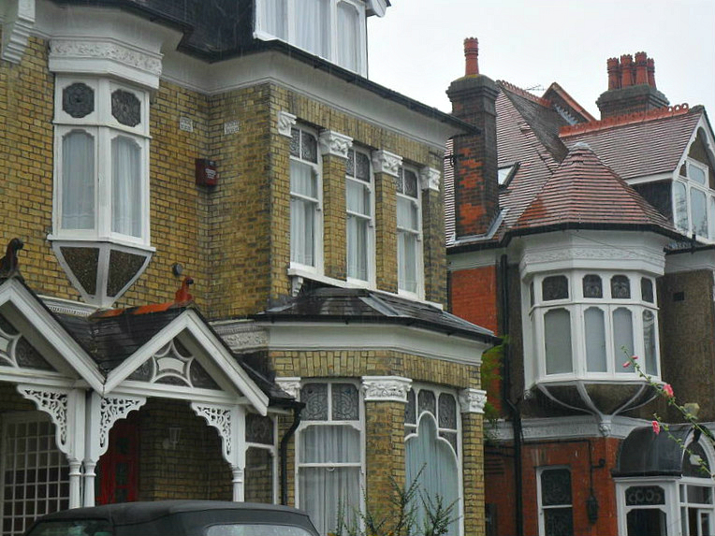Colour: lighter colours were used; the use of gas and later electric lights caused designers to be less concerned about the need to disguise soot buildup on walls compared to Victorian era architecture.
* Patterns: "Decorative patterns were less complex; both wallpaper and curtain designs were more plain."
* Clutter: "There was less clutter than in the Victorian era. Ornaments were perhaps grouped rather than everywhere."

Country squires commonly enjoy tea parties and hunting. The scenes in *Downton Abbey* is typical of post-Edwardian life-style.

3. **Romance is a prose narrative treating imaginary characters involved in events remote in time or place and usually heroic, adventurous, or mysterious. It can also refer to a medieval tale based on legend, chivalric love and adventure, or the supernatural. However, nowadays, most people perceive itsimply as a love story especially in the form of a novel.**

**Gothic fiction**, which is largely known by the subgenre of **Gothic horror**, is a genre or mode of literature and film that combines fiction and horror, death, and at times romance. Its origin is attributed to English author Horace Walpole, with his 1764 novel *The Castle of Otranto*, subtitled (in its second edition) "A Gothic Story." **The effect of Gothic fiction feeds on a pleasing sort of terror, an extension of Romantic literary pleasures that were relatively new at the time of Walpole's novel. It originated in England in the second half of the 18th century and had much success in the 19th, as witnessed by Mary Shelley’s *Frankenstein* and the works of Edgar Allan Poe.** The name *Gothic* refers to the (pseudo)-medieval buildings, emulating Gothic architecture, in which many of these stories take place. This extreme form of romanticism was very popular in England and Germany.

**Critical Reading**

**I Understanding the text**

1. Questions

(1) He would like to cure his nerve in the country. He might have been lived in the city before he tried rest cure in this rural retreat.

(2)He doubted whether it would work. (See para. 2 "Privately he doubted more than ever whether these formal visits on a succession of total strangers would do much towards helping the nerve cure which he was supposed to be undergoing.")

(3)He wondered whether the host of this house was still alive, for the male traces were evident in the room. (See para. 9 "He was wondering whether Mrs. Sappleton was in the married or widowed state. An indefinable something about the room seemed to suggest masculine habitation.")

(4)French windows are a pair of glass doors which you go through into a garden or onto a balcony. It is unusual since the weather was always cool in October.

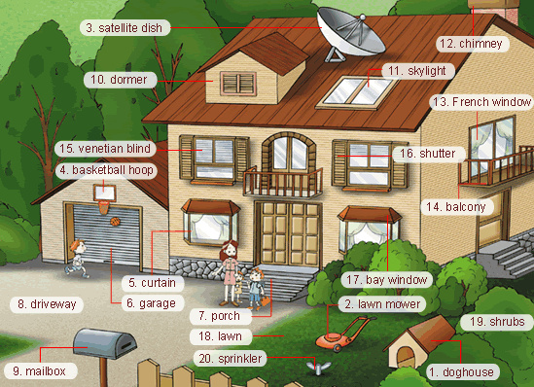



(5) Mrs. Sappleton might think of Mr. Nuttelas an eccentric man, for he wasawkward in both conversation and behaviour. (See Para. 27.) (Third person limited point of view of Mrs. Sappleton accounts for this opinion.)

2. True or false

(1)F (not very few, a succession of total strangers) (Para. 2) (all the people his sister knows) (Para. 3)

(2)T (Framtonendeavoured to say the correct something which should duly flatter the niece of the moment without unduly discounting the aunt that was to come.) (Para. 1)

(3)F (The reason is that Framton tried to turn the talk to a less ghastly topic.) (para.19)

(4)T(Romance at short notice was her specialty.) (Para. 29)

3. Multiple choices

(1) A

(2) A

(3) D

(4)C

**II Critiquing the text**

(1) "Nuttle"suggests that Framton is a nut, which means he is crazy or foolish. Both are very true in the context of this short story. He needs rest cure for his nerves and Vera made a fool of him by improvising the story.

(2) Because his doctors all agreed in ordering him complete rest and he moved to the country to seek absence of mental exercises and avoidance of any violent physical exercise. It can be inferred that he lived in the city before, and led an eventful life of both mental and physical challenges.

(3) Mrs. Sappleton should belong to the leisure class, for she owns a mansion with gravel drive and both her husband and her don't have to work. She was so keen to talk about hunting for it's an aristocratic tradition; besides, autumn and winter are good seasons for hunting (the story is set in October). Mrs. Sappleton is self-centered or self-possessed, like her niece, both of whom care little about true feelings of visitors.

(4) Vera is an intelligent, mischievous and manipulative. She acted and thoughtlikean adult instead of a teenager. She played such a practical joke on FramtonNuttle for her own fun. The last line implies that it is not the first time that she makes fool of a visitor nor will it be the last time; moreover, the last line will invite readers to reread the text.

(5) (The following are some interpretations from online resources.)

Themes

Though it is a remarkably short piece of fiction, “The Open Window” explores a number of important themes. Mr. Nuttel comes to the country in an attempt to cure his nervous condition. He pays a visit to the home of Mrs. Sappleton in order to introduce himself, and before he gets to meet the matron of the house, he is intercepted by her niece, who regales him with an artful piece of fiction that, in the end, only makes his nervous condition worse.

Appearances and Reality

It is no surprise that Mrs. Sappleton’s niece tells a story that is easy to believe. She begins with an object in plain view, an open window, and proceeds from there. The window is obviously open, but for the reasons for its being open the reader is completely at the mercy of Mrs. Sappleton’s niece, at least while she tells her story. The open window becomes a symbol within this story-within-a-story, and its appearance becomes its reality. When Mr. Nuttel (and the reader) are presented with a contrary reality at the end of the story, the result is a tension between appearance and reality that needs to be resolved: Which is real? Can they both be real?

Deception

Were it not for deception, this story could not happen. The action and irony of the story revolve around the apparent deception that Mrs. Sappleton’s niece practices. It remains to be seen, however, whether this deception is a harmless prank or the result of a sinister disposition. If the niece’s deception is cruel, then the reader must question the motives behind the deception practiced by all tellers of stories, including Saki himself.

Sanity and Insanity

“The Open Window” shows just how fine the line can be between sanity and insanity. Mr. Nuttel’s susceptibility to deceit is no different from that of the reader of the story. Yet Mr. Nuttel is insane, and the reader, presumably, is not. In order to maintain this distinction, Saki forces his reader to consider the nature of insanity and its causes.

(6) A **ghost story** may be any piece of fiction, or drama, that includes a ghost, or simply takes as a premise the possibility of ghosts or characters' belief in them. The "ghost" may appear of its own accord or be summoned by magic. Linked to the ghost is the idea of "hauntings", where a supernatural entity is tied to a place, object or person.

Colloquially, the term "ghost story" can refer to any kind of scary story. In a narrower sense, the ghost story has been developed as a short story format, within genre fiction. It is a form of supernatural fiction and specifically of weird fiction, and is often a horror story.

While ghost stories are often explicitly meant to be scary, they have been written to serve all sorts of purposes, from comedy to morality tales.

Ghost story elements in this story are:

**Plot**

Framton is persuaded that the house, esp. the French window, is haunted.

Vera's voice and facial expressions in making up the story are scary.

Mrs. Sappleton's bustling demeanor might imply an illusion of an insane woman suffering from the ghosts of her husband and her two young brothers, though in the end readers are aware of the truth.

The portrayal of the homecoming scene in the para. 24 is ghastly.

The color of the coat of Mr. Sappleton is white, a traditional color for ghosts.

**Vocabulary of horror**

bury, soul, moping (para. 3)

never came back, were all three engulfed in a treacherous piece of bog, their bodies were never recovered, dreadful, still quiet evening, creepy feeling (para. 14)

shudder (para. 15)

horrible, desperate, ghastly, tragic (para. 19)

shiver, sympathetic, stare, dazed horror, shock of nameless fear (para. 23)

deepening twilight, figures, noiselessly, hoarse, chant (para. 24)

(7)Foreshadowing is the presentation of details, characters, or incidents in a narrative in such a way that later events are prepared for (or "shadowed forth"). Foreshadowing, says Paula LaRocque, can be "a highly effective means of preparing the reader for what is to come." This storytelling device can "create interest, build suspense, and provoke curiosity" (The Book on Writing, 2003).

**In this story:**

the cause why the window is open by Vera (para. 14) vs. the cause why the window is open by Mrs. Sappleton (para. 18)

the white waterproof coat (para. 14) vs. a white coat(para. 24) and the white mackintosh (para. 26)

little brown spaniel (para. 14) vs. a tired brown spaniel (para. 24)

Ronnie singing 'Bertie, why do you bound?'(para. 14) vs. a hoarse young voice chanted out of the dusk: " I said, Bertie, why do you bound"(para. 24)

**Other cases of foreshadowing**

The witches in the opening scene of Shakespeare's Macbeth**foreshadow** the evil events that will follow.

**Language Enhancement**

**I Word and Phrases**

1.

(1) self-centred, self-addressed

(2) headfast, headless, headway

(3) scornful, respectful

(4) unquestionable, unintended

(5) tighten, sweeten

(6) enable, enrich

2.

(1) made an appearance(2) made a mess; make amends(3) make an effort(4) make sense(5) made a scene(6) make a deal

3.

(1) put up with(2) went off for(3) give way

(4)broke off(5)bolted out/ dashed off(6)dash off

(7)undergo (8) discount (9) migrate (10) endeavor

(11) mope (12) pursue (13) bustled (14) rattling

(15) straying (16) chanted

**II Sentences and rhetoric**

1. Paraphrase
2. Translation

(1) 弗兰姆顿•纳特尔努力想说点儿什么得体的话，既能够讨眼前这个小姑娘欢心，又不至于怠慢她那位待会儿要下来的姨妈。

(2)他竭力想把交谈转向不太瘆人的话题但并不完全成功。他感觉到，女主人对他心不在焉，她的目光常常略过他，投向那面法式落地窗和远处的草坪。

(3)弗兰姆顿惊恐地去抓他的手杖和帽子，在他仓惶逃离的过程中隐约意识到经过了屋前的砾石车道和大门。

(4)他在印度时被一群野狗追到恒河附近的一个墓地里，不得不在一个新挖的坟洞里过夜，那群狗就在他上面，龇牙咧嘴，冒着白沫，不停地狂叫。

(5)Life is presented as a succession of “ages”: from birth, through babyhood, infancy, childhood, adolescence, adulthood, middle age, and finally old age.

(6)I feel quite awkward and out of place, for I know no one here at the party.

(7)Thank you so much for coming to our aid at such short notice.

(8)After reading Wuthering Heights, I am hungry for a trip to see the place in which the author once lived.